FINAL MAJOR PROJECT

## Part 1: Project Proposal

Step 1: Bookroom.com web-app development final major project in ASP.NET

**Systems Analysis –** We used ASP.NET for this platform. The main functionality is based on the feature to book a room. We ran an investigation of the requirements of the target system with an emphasis on user needs, includes understanding of software product limitations, learning system related problems or changes and addressing the impact of project on organization and personnel etc.

The project team analyzed the scope of the project and plans the schedule and resources accordingly.

**Systems design** – This is an overall coverage of the way the requirements will be met by a computer-based system – it is expected to be a single-user system with **no** dependency on data-communication for the primary facility.

**Systems Specifications**

OS -Windows 10

IDE- Visual Studio

**Programming** – ASP.NET and C# was used to the nominated functionality completed as a working system in an MVC model.

Step 2***:*** Produced a project proposal contained that includes room location, Car size, Car price and User login etc.

Project Goal – Build a platform for users to book a room.

Project Objectives – The main objectives of the project was to enable users to book room easily and provide an optimal user interface and user experience

Project Scope – A full-fledge website develop 5 page website development

1. Context – A room booking facility
2. ASP.NET language platform
3. Stakeholders of the product: People who want to book room
4. Backend or API integration

Project Deliverables – List exactly what you intend to include in the final package

1. Analysis documentation
2. Design documentation
3. Executable program
4. User documentation

|  |  |  |
| --- | --- | --- |
| **Milestone** | **Time taken** | **Finalized** |
| Designing | 2 Days | Yes |
| Programming | 2 Days | Yes |
| Documentation | 2 days | Yes |

Resources

|  |  |
| --- | --- |
| Processor | 1 GHz |
| RAM | 512 MB |
| Disk space (minimum) |  |
| 32-bit | 4.5 GB |
| 64-bit | 4.5 GB |

ProjectMilestones

|  |  |  |
| --- | --- | --- |
| **Milestone** | **Time taken** | **Finalized** |
| Designing | 2 Days | Yes |
| Programming | 2 Days | Yes |
| Documentation | 2 days | Yes |

ProjectSchedule

1. Completion of initial investigation
2. Design Drafted
3. Design signed-off
4. Prototype program completed
5. Stages of program refinement signed-off
6. Program completed
7. Program tested
8. System documentation completed
9. User acceptance completed
10. User report on system acceptability completed

Project Assumptions

1. Users are available during the project to provide information and software is available at the client site.
2. if the admin is login then only he can add new rooms to the project and user can book the room

# **Design**:

# WhatsApp Image 2021-08-05 at 22.14.55.jpegWhatsApp Image 2021-08-05 at 22.15.55.jpegWhatsApp Image 2021-08-05 at 22.16.27.jpeg

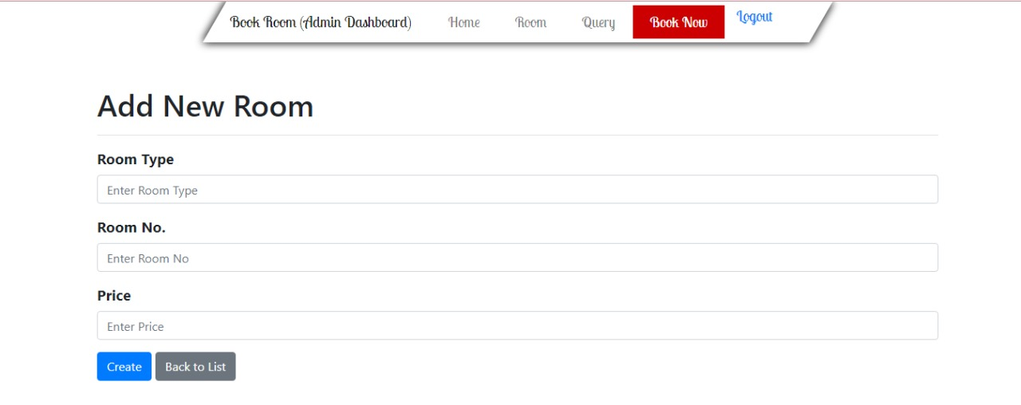

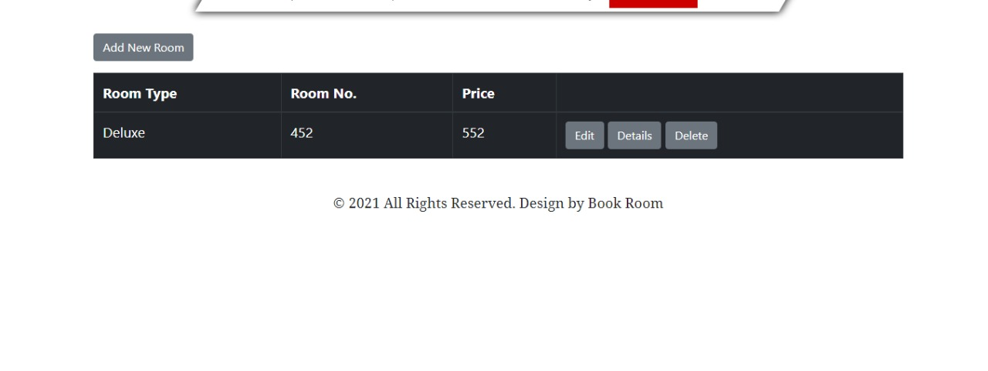

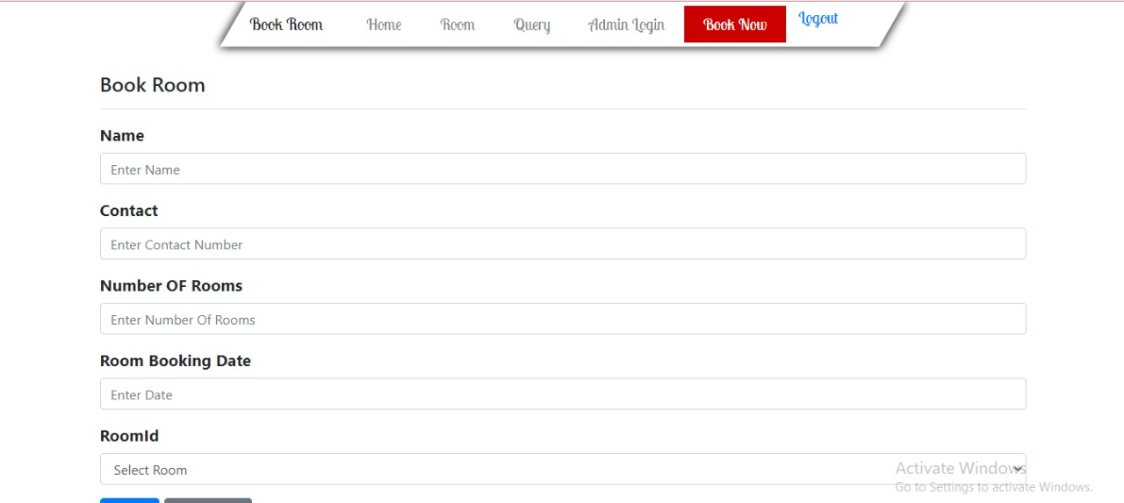

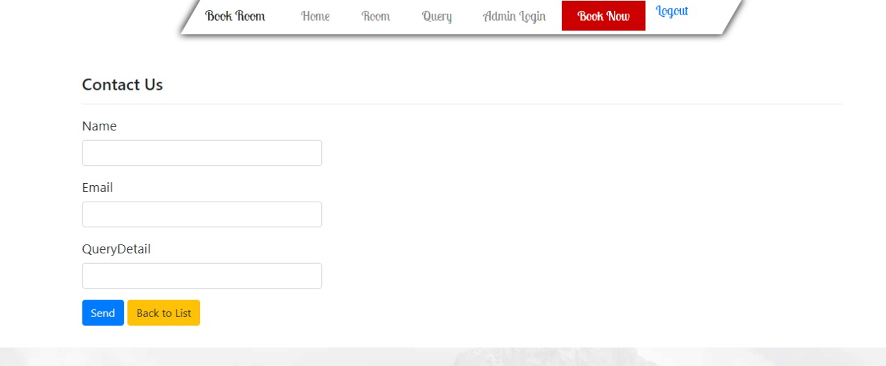

# **Part 2: Review your project**

Step 1: Final Product/Outcome - a platform to book rooms